**Citizen AI – Intelligent Citizen Engagement Platform**

**1.INTRODUCTION:**

**1.1 Project Overview**

Citizen AI is an AI-powered civic engagement platform designed to bridge the communication gap between citizens and local authorities. With a chatbot interface, real-time feedback, and sentiment dashboards, it empowers users to report local problems easily while enabling civic bodies to make data-informed decisions.

**1.2 Purpose**

The purpose of Citizen AI is to foster a transparent and inclusive governance model by offering a unified digital platform where citizens can raise issues, track resolutions, and feel heard—leading to a more responsive and accountable municipality.

**2.IDEATION PHASE**

**2.1 Problem Statement**

Citizens often face delayed responses or inaction due to fragmented civic complaint systems. Many resort to informal channels like social media where their concerns remain unresolved and untracked.

**Problem Statement (PS-1):**

I am a local citizen trying to report issues like a broken streetlight or water supply outage, but I don’t know where or how to raise them. Even when I attempt to report, I rarely receive a response—because existing systems are fragmented, slow, or too complex to access. This leaves me feeling frustrated, unheard, and disconnected from civic processes.

**Problem Statement (PS-2):**

I am a municipal officer responsible for civic feedback and service delivery. I’m trying to gather insights from citizens and track public sentiment on key issues. But I receive scattered complaints through multiple channels with no centralized tracking—because there is no automated tool to organize, analyze, and respond at scale. This makes me feel overwhelmed and unable to prioritize or respond effectively.

**2.2 Empathy Map Canvas**

👤 **Citizen User**

* **Says**: “No one responds when I report issues.”
* **Thinks**: “Will this ever be fixed?”
* **Feels**: Frustrated, ignored
* **Does**: Posts on social media, avoids official apps

🧑‍💼 **Municipal Officer**

* **Says**: “Complaints come from everywhere.”
* **Thinks**: “I can’t prioritize without insights.”
* **Feels**: Overwhelmed, unsupported
* **Does**: Checks scattered sources, struggles to respond on time

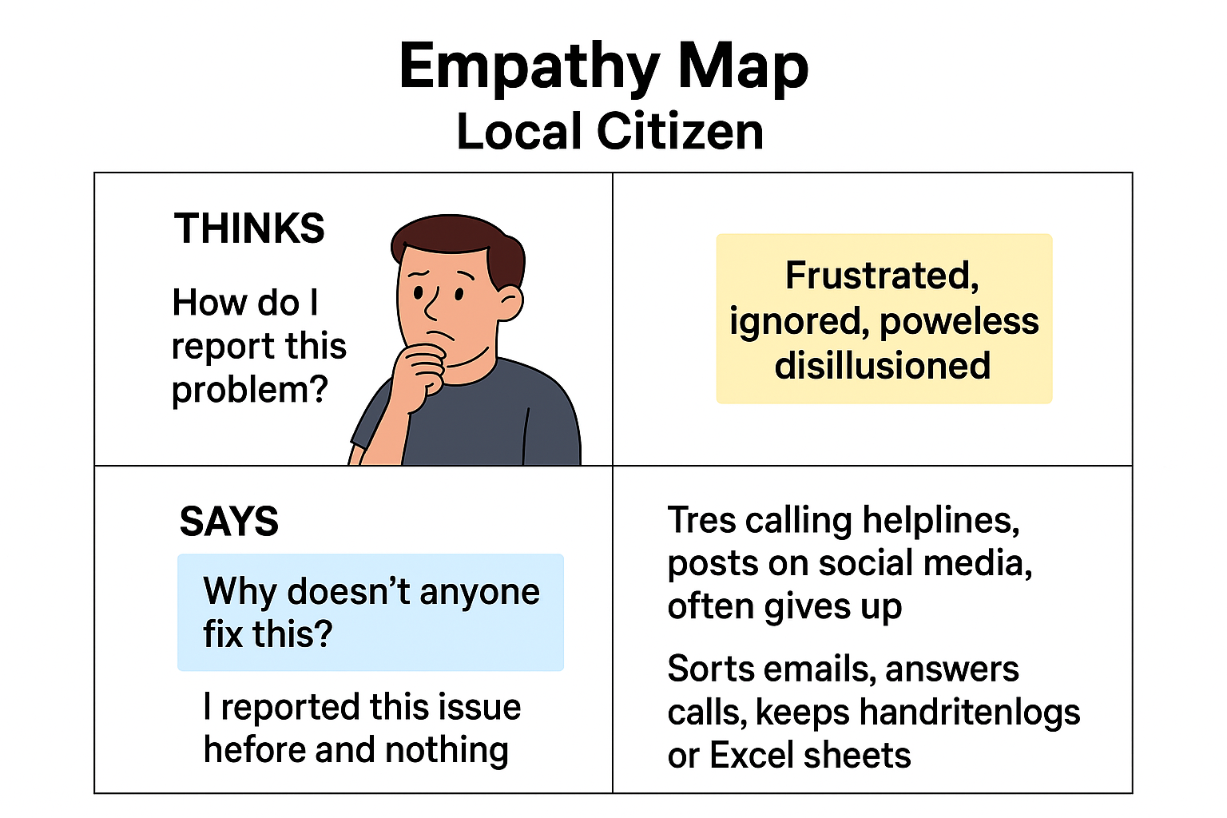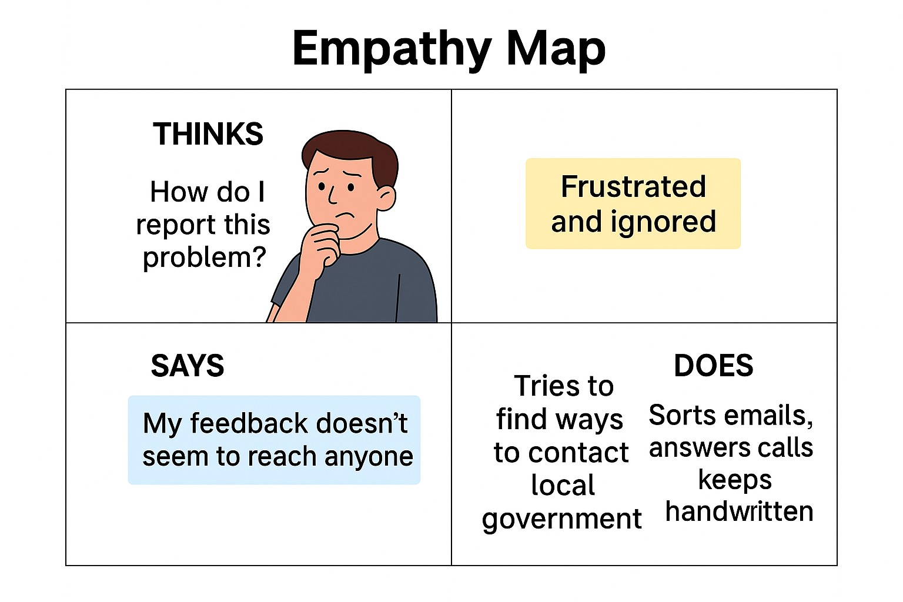

**2.3 Brainstorm & Idea Prioritization**

**Step 1: Team Collaboration and Problem Selection**

**Challenge:** Citizens face difficulty communicating with civic authorities. Issues are reported slowly or lost altogether, and there’s no modern, intelligent system for managing feedback or community sentiment.

**Solution Goal**: Design an AI-powered platform where users can ask civic-related questions, submit concerns, and provide feedback—all while helping civic officials visualize and act on this data through an admin dashboard.

**Step 2: Idea Listing and Grouping**

|  |  |  |
| --- | --- | --- |
| Idea No. | Description | Group / Category |
| 1 | Integrate GPT-based chatbot for instant civic query resolution | Core Functionality |
| 2 | Use sentiment analysis on user feedback | Public Insight & Analytics |
| 3 | Concern submission with issue tagging and descriptions | Issue Management |
| 4 | Dashboard for authorities to track feedback and complaints | Admin Utility |
| 5 | Secure login access for authorized administrators | Authentication & Security |
| 6 | Visual stats showing user sentiments (pie/bar charts) | Data Visualization |
| 7 | Add multilingual capability in chatbot | Accessibility Enhancement |
| 8 | Alert system via email for high-priority or repeated complaints | Communication Automation |

**Step 3: Idea Prioritization**

|  |  |  |
| --- | --- | --- |
| Priority Level | Idea Numbers | Reasoning |
| High Impact – High Feasibility | 1, 2, 3, 4 | Core project features that are achievable with available tools and effort |
| High Impact – Medium Feasibility | 5, 6 | Important additions requiring authentication and data rendering logic |
| Medium Impact – Low Feasibility | 7, 8 | Future-ready features that enhance user reach and real-time alerts |

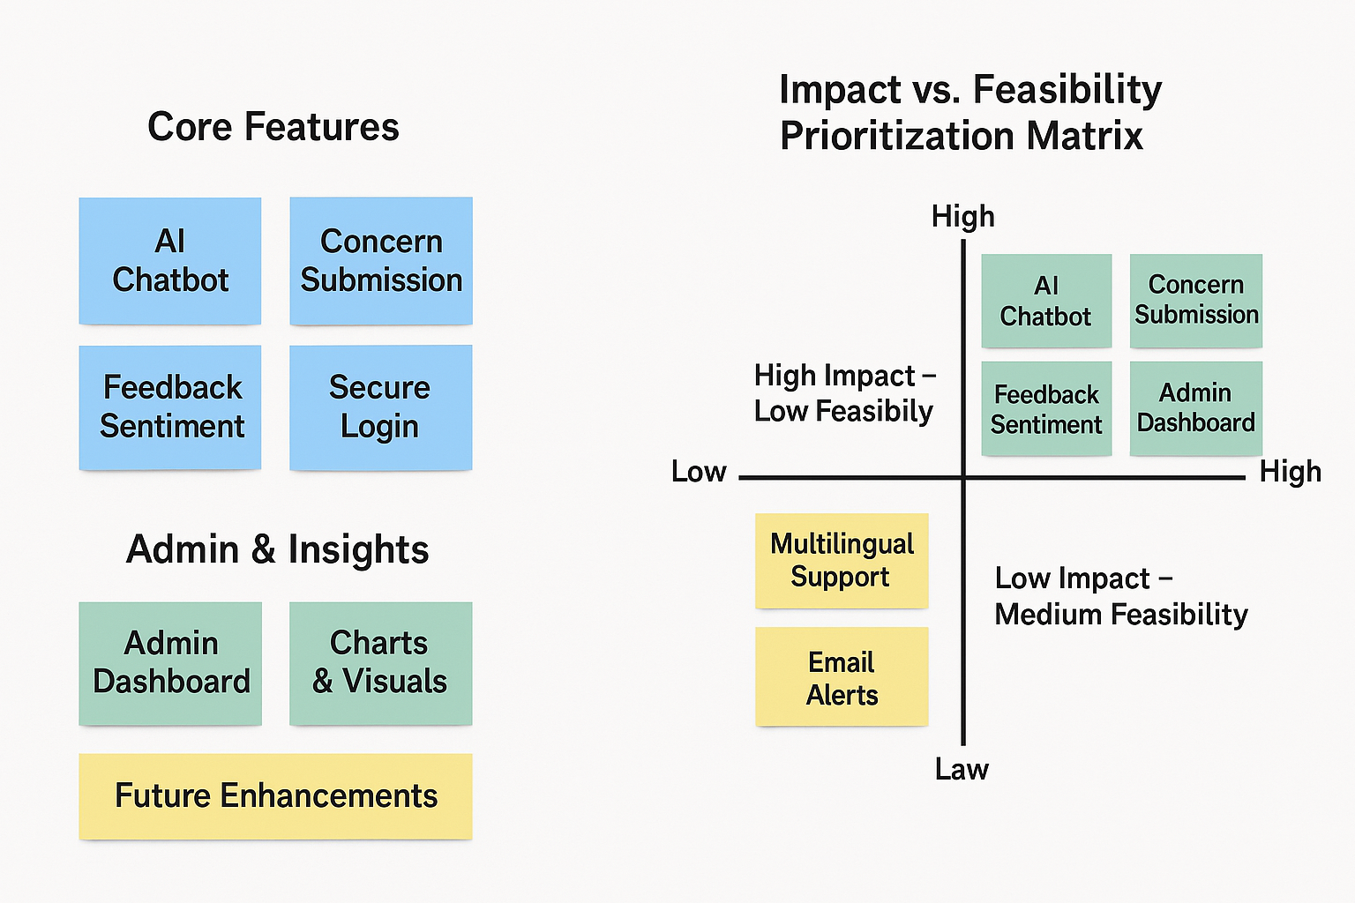

**3. REQUIREMENT ANALYSIS**

**3.1 Customer Journey map**

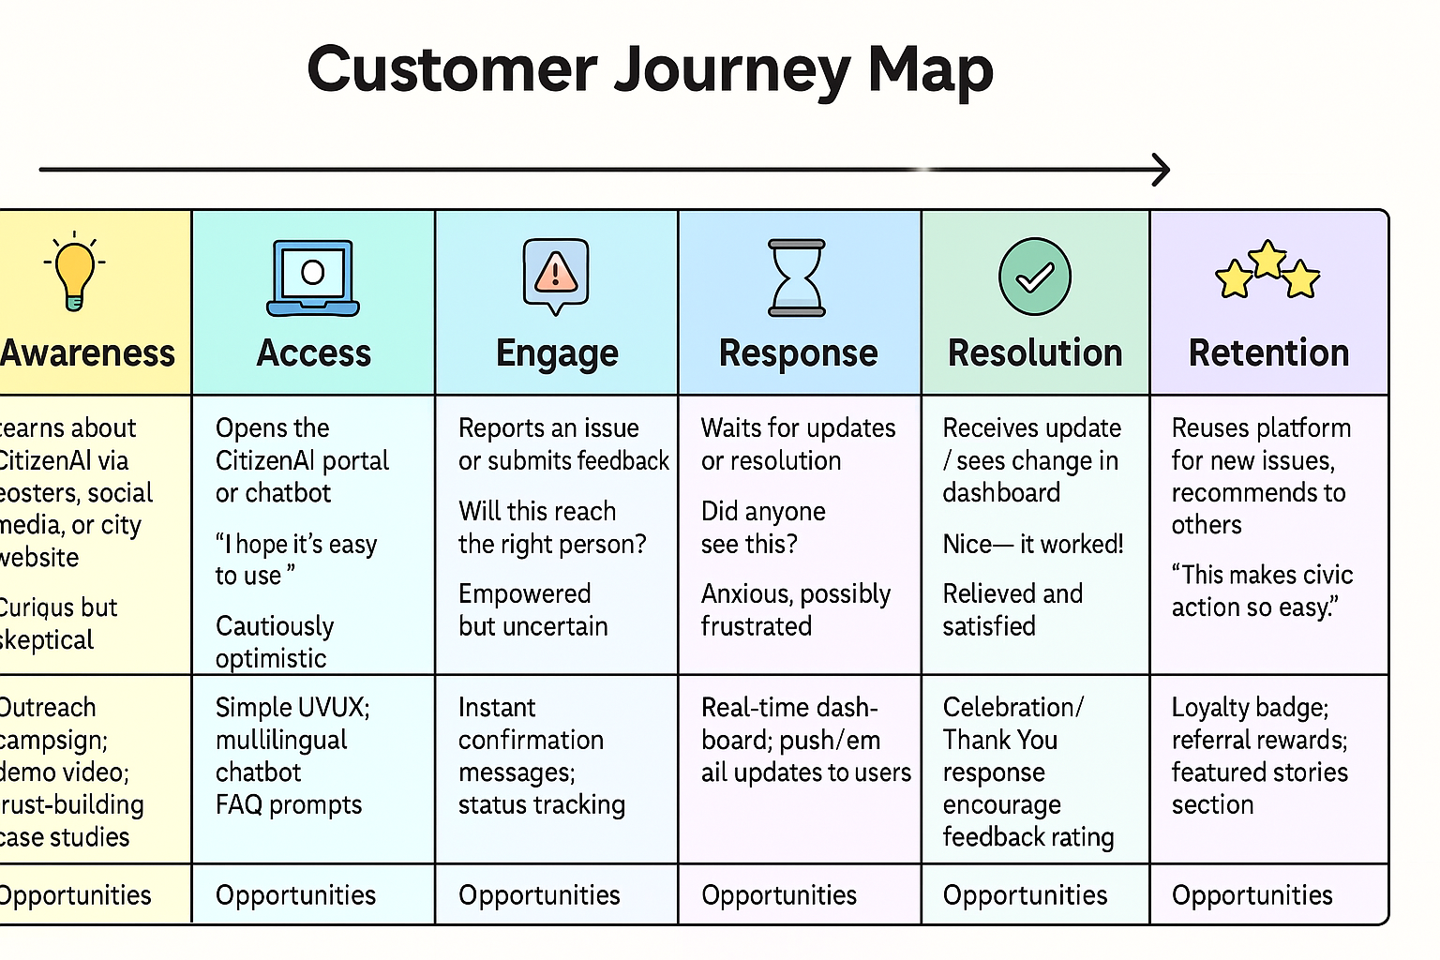

**3.2 Solution Requirement**

**Functional Requirements**

|  |  |  |
| --- | --- | --- |
| **FR No.** | **Functional Requirement (Epic)** | **Sub Requirement (Story / Sub-Task)** |
| FR-1 | User Registration | Registration through Email Form Registration with Gmail Registration with LinkedIn |
| FR-2 | User Confirmation | Confirmation via Email Confirmation via OTP |
| FR-3 | Civic Interaction | Chatbot interaction for FAQs Submit feedback Report local issues |
| FR-4 | Admin Panel | Admin login View complaints and feedback View sentiment visualizations |

**🔒 Non-functional Requirements**

|  |  |  |
| --- | --- | --- |
| **NFR No.** | **Non-Functional Requirement** | **Description** |
| NFR-1 | Usability | Clean and intuitive interface for both citizens and administrators |
| NFR-2 | Security | Role-based access, secure login, and feedback protection |
| NFR-3 | Reliability | Ensures stable performance even under multiple user requests |
| NFR-4 | Performance | Response time for queries should be under 2 seconds |
| NFR-5 | Availability | 99% uptime expected during active hours |
| NFR-6 | Scalability | Designed to support additional users, languages, and regional dashboards easily |

**3.3 Data Flow Diagram**

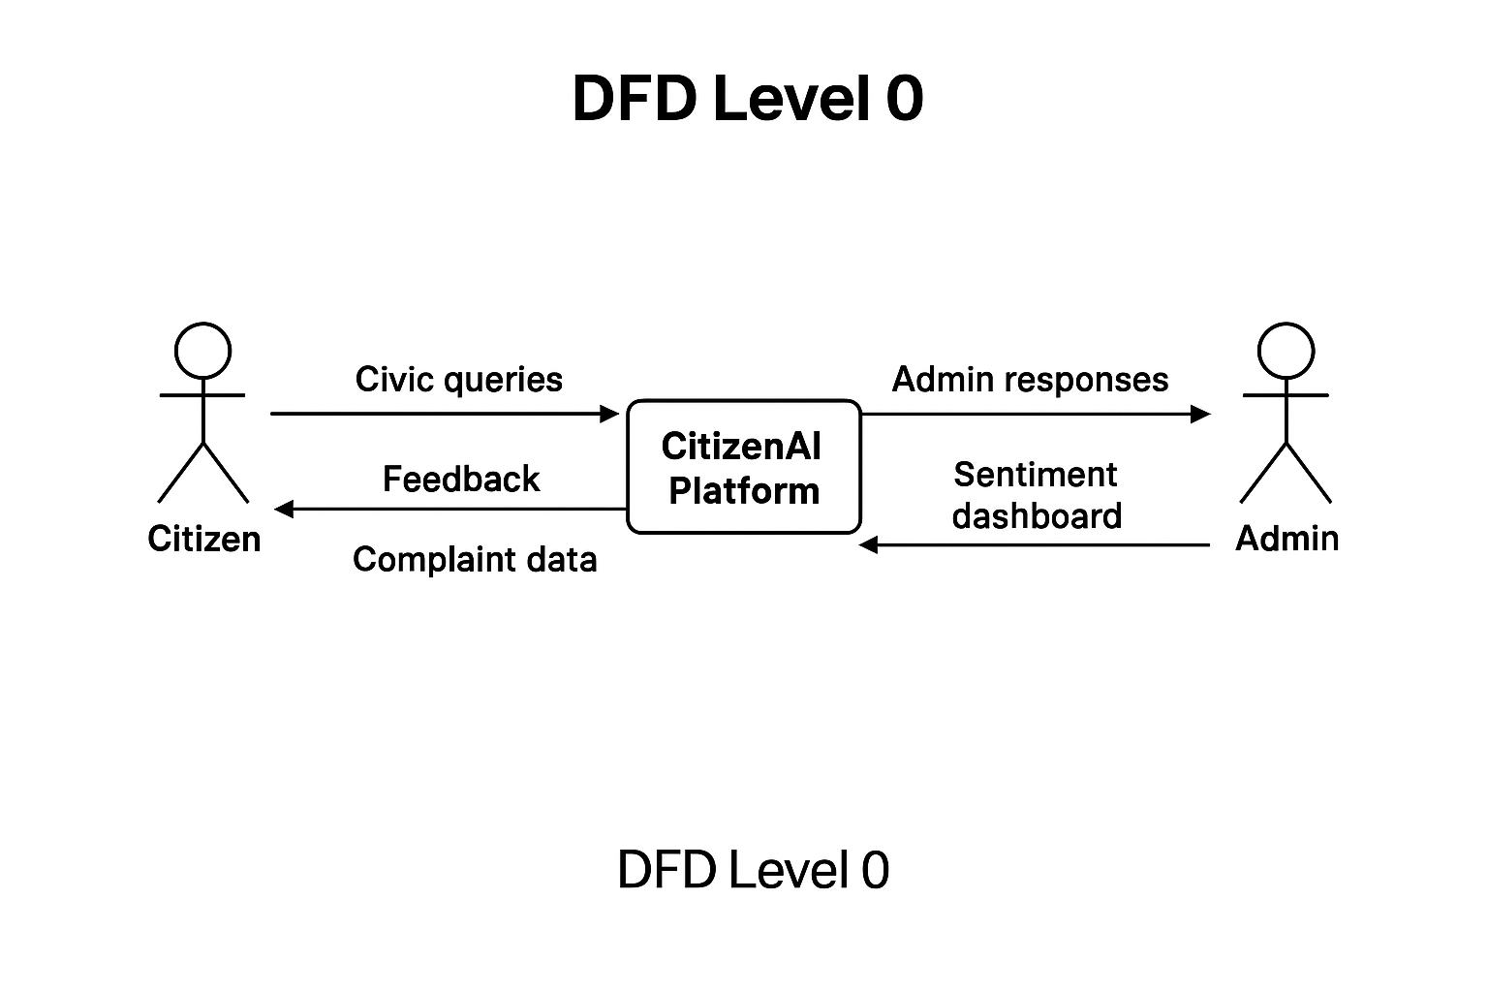

Level 0 DFD

Shows the **overall system as a black box**

* **External Entities**: Citizen User and Municipal Admin
* **System**: CitizenAI Platform
* **Data Flows**:
* Citizens send queries, feedback, and complaints
* System sends responses and confirmations
* Admins receive data dashboards and send action updates

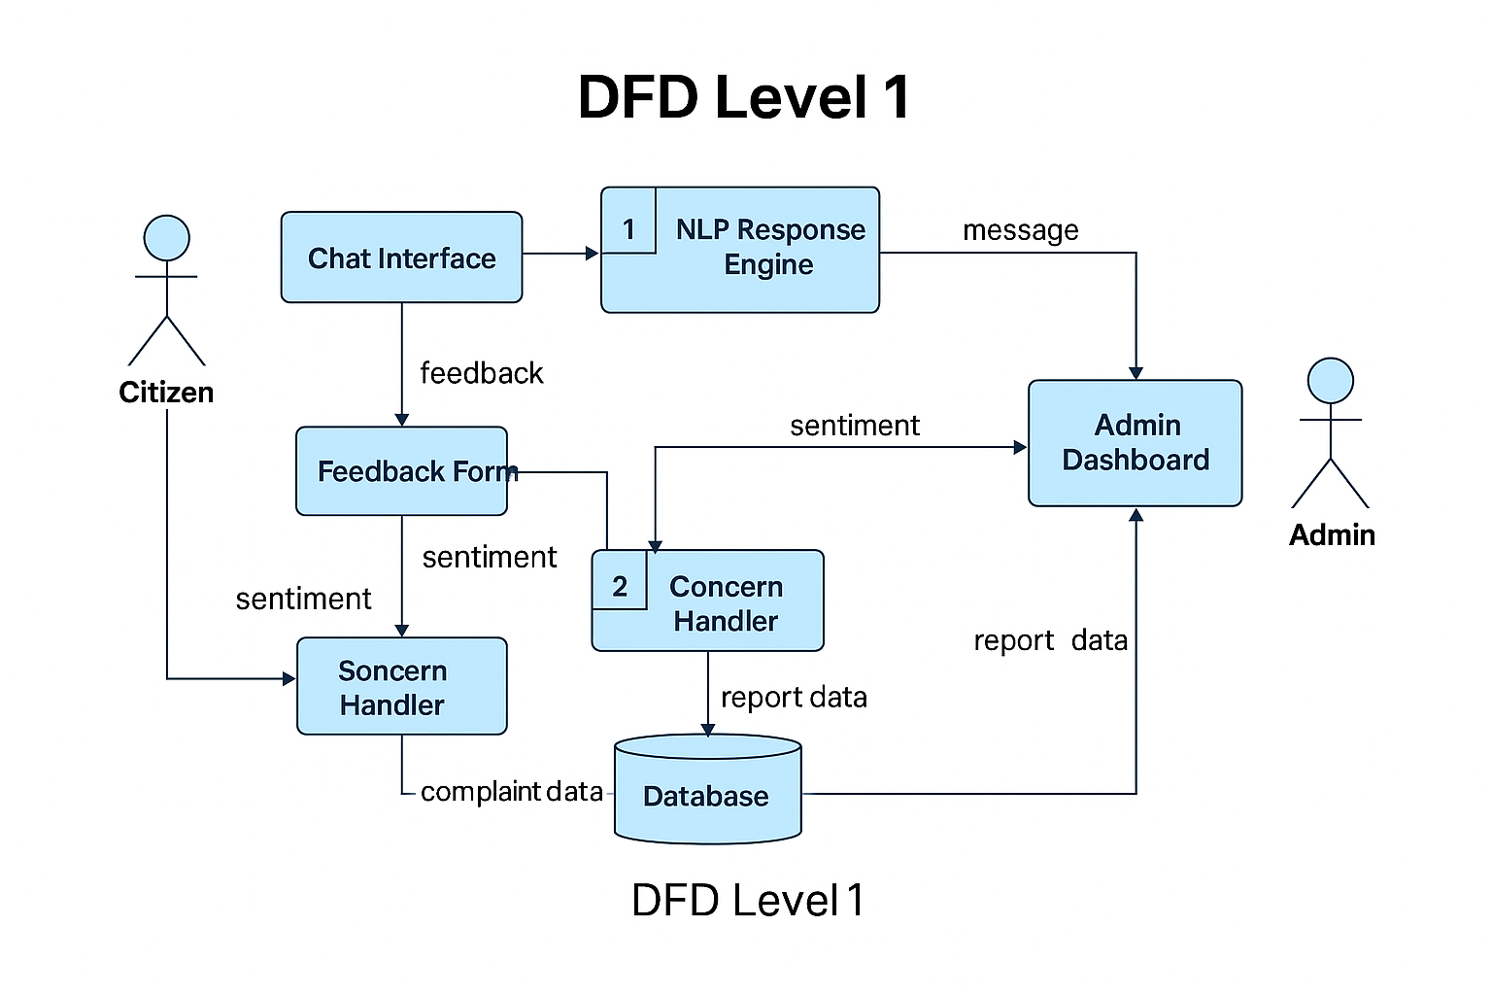

Level 1 DFD – *Detailed System Flow*

* Breaks down internal modules of CitizenAI
* **Main Components**:
  + Chat Interface → Handles citizen interaction
  + NLP Engine → Processes text and extracts intent
  + Sentiment Analyzer → Evaluates emotional tone of feedback
  + Concern Handler → Sorts and stores civic issues
  + Database → Stores reports, responses, user info
  + Admin Dashboard → Visualizes issues and responses for officers
* **Data Paths**:
* Citizen input → Chatbot → AI Logic → Database/Admin
* Admin actions → Updates → Stored & shown to user via system

**3.4 User Stories**

Organized by user role and mapped with user story IDs, goals, and priorities:

**👤 User Type: Citizen**

|  |  |  |  |  |
| --- | --- | --- | --- | --- |
| **User Story ID** | **User Story / Task** | **Acceptance Criteria** | **Priority** | **Release** |
| US-C1 | As a citizen, I can chat with an AI assistant to ask questions about services or departments. | The bot replies with accurate, prompt answers. | High | Sprint-1 |
| US-C2 | As a citizen, I can submit feedback with a rating or comment. | Feedback is submitted and tagged with sentiment. | High | Sprint-1 |
| US-C3 | As a citizen, I can report civic problems by filling out a form with type, location, and details. | The report is stored and visible in the admin dashboard. | High | Sprint-2 |
| US-C4 | As a citizen, I can chat in my regional language (e.g. Telugu or Hindi). | Multilingual support works correctly. | Low | Sprint-4 (Future) |

**🧑‍💼 User Type: Admin (Municipal Officer)**

|  |  |  |  |  |
| --- | --- | --- | --- | --- |
| **User Story ID** | **User Story / Task** | **Acceptance Criteria** | **Priority** | **Release** |
| US-A1 | As an admin, I can securely log into the system. | Login works only with valid credentials. | Medium | Sprint-2 |
| US-A2 | As an admin, I can view submitted concerns in a list format. | Concern data is filterable by category or date. | High | Sprint-3 |
| US-A3 | As an admin, I can view feedback sentiments in bar/pie chart formats. | Charts reflect live feedback data. | Medium | Sprint-3 |
| US-A4 | As an admin, I get automatic email alerts when certain issues exceed frequency thresholds. | Emails sent to registered addresses on threshold breach. | Low | Sprint-5 (Future) |

**3.4 Technology Stack**

**Table 1: Components & Technologies**

|  |  |  |  |
| --- | --- | --- | --- |
| **S.No** | **Component** | **Description** | **Technology** |
| 1 | User Interface | Web UI + Chatbot for citizen interaction | HTML, CSS, JavaScript, Bootstrap |
| 2 | Application Logic - 1 | AI-based text processing and query handling | Python (Flask), Hugging Face GPT-2 |
| 3 | Application Logic - 2 | Sentiment Analysis module for feedback | Python TextBlob / NLTK |
| 4 | Application Logic - 3 | Dashboard logic for real-time visualization | Chart.js / Plotly + Flask Backend |
| 5 | Database | Store concerns, feedback, user data | SQLite (Local) / PostgreSQL (Cloud Ready) |
| 6 | Cloud Database (optional) | Database hosted on the cloud (for scale) | Azure PostgreSQL / Firebase Firestore |
| 7 | File Storage (optional) | Local file uploads or image storage | OS Filesystem / Firebase Storage |
| 8 | External API - 1 (Optional) | Geo-tagging civic complaints | Google Maps API |
| 9 | Machine Learning Model | Natural language responses | Hugging Face Transformers (GPT-2) |
| 10 | Infrastructure | Deployment & Hosting | Localhost, Azure App Services, PythonAnywhere |

**⚙️ Table 2: Application Characteristics**

|  |  |  |  |
| --- | --- | --- | --- |
| **S.No** | **Characteristics** | **Description** | **Technology** |
| 1 | Open-Source Frameworks | Rapid development and deployment | Flask, Bootstrap, Chart.js |
| 2 | Security Implementations | Protect admin access and inputs | Flask-Login, SHA-256 Encryption |
| 3 | Scalable Architecture | Easily expandable modules and layers | 3-Tier Architecture, RESTful APIs |
| 4 | Availability | Accessible 24/7 with local fallback | Azure Hosting + Auto-Restart Scripts |
| 5 | Performance | Optimized for low-latency response & visualization | Caching, Asynchronous Requests, JS Minify |

**4. PROJECT DESIGN**

**4.1 Problem Solution Fit**

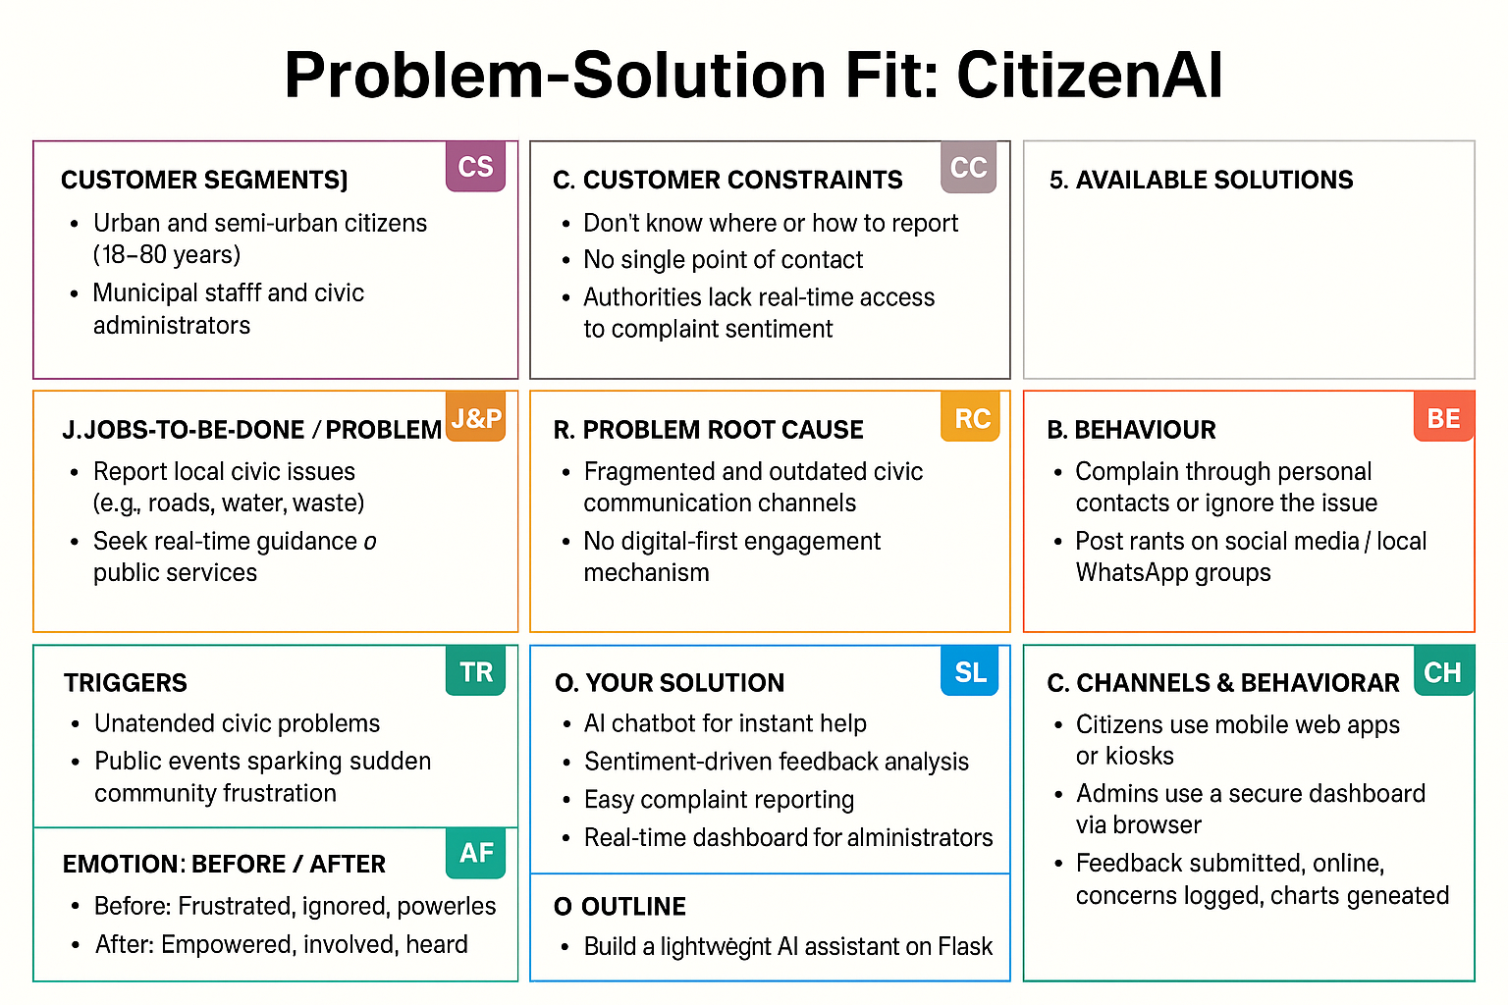

**4.2 Proposed Solution**

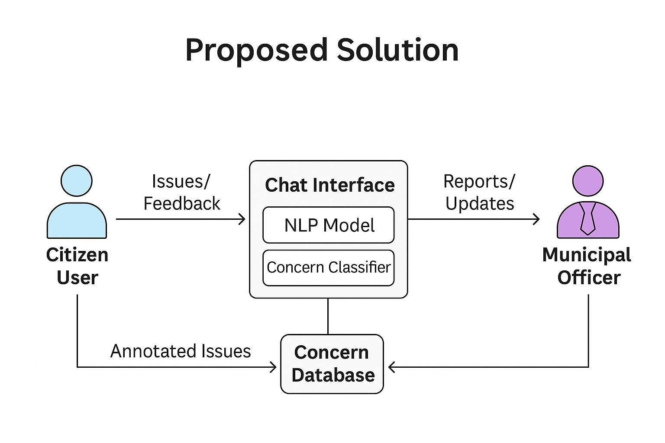

|  |  |
| --- | --- |
| **Section** | **Citizen AI Insight** |
| Customer Segments (CS) | - Urban and semi-urban citizens (18–60 years) - Municipal staff and civic administrators |
| Jobs-to-be-Done (J&P) | - Report local civic issues (e.g., roads, water, waste) - Seek real-time guidance on public services - Aggregate and review complaints efficiently |
| Customer Constraints (CC) | - Don’t know where or how to report - No single point of contact - Authorities lack real-time access to complaint sentiment |
| Root Cause (RC) | - Fragmented and outdated civic communication channels - No digital-first engagement mechanism |
| Behaviour (BE) | - Complain through personal contacts or ignore the issue - Post rants on social media or local WhatsApp groups |
| Triggers (TR) | - Unattended civic problems - Public events sparking sudden community frustration |
| Emotion: Before / After | - Before: Frustrated, ignored, powerless - After: Empowered, involved, heard |
| Your Solution (SL) | - AI chatbot for instant help - Sentiment-driven feedback analysis - Easy complaint reporting - Real-time dashboard for administrators |
| Channels & Behaviour (CH) | - Citizens use mobile web apps or kiosks - Admins use a secure dashboard via browser - Feedback submitted online, concerns logged, charts generated |
| Outline (O) | - Build a lightweight AI assistant on Flask - Connect Text Blob for sentiment - Store & visualize data - Provide role-based admin access |

**4.3 Solution Architecture**

The solution architecture of Citizen AI is built to be intuitive, lightweight, and effective. It begins with a user-facing web interface where citizens can interact via a chatbot, submit feedback, and log complaints. These interactions flow through a Python Flask backend, where modules like GPT-2 (for generating responses) and Text Blob (for sentiment analysis) process the data. Reports and feedback are logged into a backend structure, which feeds into an admin dashboard. There, civic officials can securely log in, review real-time sentiment graphs, and address issues efficiently. The architecture is modular and scalable, allowing future integration of multilingual support, email alerts, and geolocation features

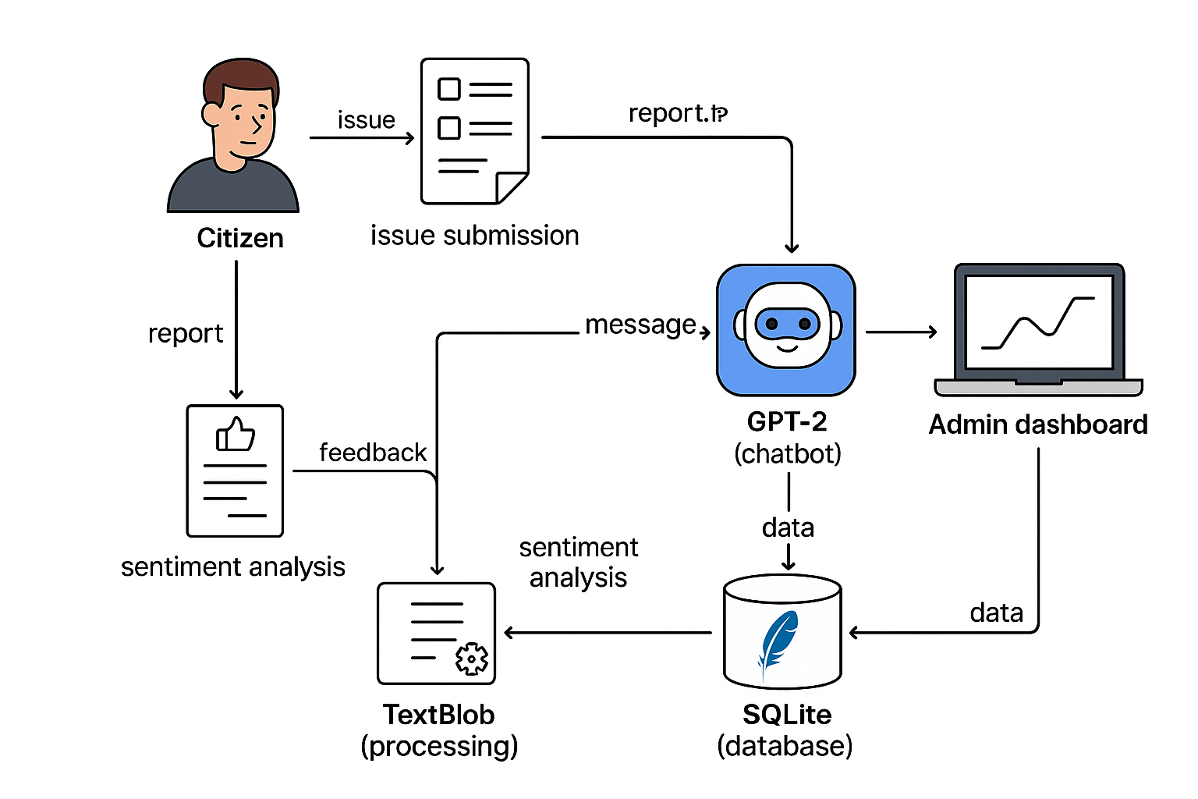

**5. PROJECT PLANNING & SCHEDULING**

**5.1 Project Planning**

✅ **Product Backlog & Sprint Breakdown**

|  |  |  |  |  |  |
| --- | --- | --- | --- | --- | --- |
| **Sprint** | **Epic / Module** | **User Story ID** | **User Story Description** | **Story Points** | **Priority** |
| Sprint-1 | Chatbot Interaction | US-001 | As a citizen, I can chat with an AI assistant to ask civic queries. | 3 | High |
| Sprint-1 | Feedback Submission | US-002 | As a citizen, I can submit feedback that will be analyzed for sentiment. | 2 | High |
| Sprint-2 | Civic Concern Reporting | US-003 | As a citizen, I can report an issue with title, category, and description. | 2 | High |
| Sprint-2 | Admin Login | US-004 | As an admin, I can log into the dashboard securely. | 2 | Medium |
| Sprint-3 | Admin Dashboard | US-005 | As an admin, I can view reported concerns and feedback analysis with graphs. | 3 | High |
| Sprint-3 | Sentiment Analytics | US-006 | As an admin, I can view aggregated sentiment results in charts. | 2 | Medium |
| Sprint-4 | Email Notification (Optional) | US-007 | As an admin, I get email alerts on frequently reported or critical issues. | 2 | Low |
| Sprint-5 | Multilingual Chatbot (Optional) | US-008 | As a citizen, I can chat with the assistant in my native language (e.g., Telugu/Hindi). | 3 | Low |

**📊 Sprint Schedule & Tracker**

|  |  |  |  |  |  |  |
| --- | --- | --- | --- | --- | --- | --- |
| **Sprint** | **Duration** | **Start Date** | **End Date** | **Story Points** | **Completed** | **Planned Release** |
| Sprint-1 | 5 Days | 23 May 2025 | 27 May 2025 | 5 | ✅ Yes | 27 May 2025 |
| Sprint-2 | 6 Days | 28 May 2025 | 2 Jun 2025 | 4 | ✅ Yes | 2 Jun 2025 |
| Sprint-3 | 5 Days | 3 Jun 2025 | 7 Jun 2025 | 5 | ⏳ In Progress | 7 Jun 2025 |
| Sprint-4 | 6 Days | 10 Jun 2025 | 15 Jun 2025 | 2 | ⏳ Planned | 15 Jun 2025 |
| Sprint-5 | 6 Days | 17 Jun 2025 | 22 Jun 2025 | 3 | ⏳ Planned | 22 Jun 2025 |
| Sprint-6 | Final Wrap-up | 24 Jun 2025 | 27 Jun 2025 | Demo, Testing, Docs | — | 27 Jun 2025 |

**⚙️ Velocity Estimation & Planning**

* Sprint-1 Velocity: 5 SP / 5 Days = 1.0 SP/day
* Estimated Team Velocity: ~1.1 story points per day
* Total Story Points Planned: 19–22 across 5 sprints

**6. FUNCTIONAL AND PERFORMANCE TESTING**

**6.1 Performance Testing**

**🚀 Performance Testing**

|  |  |  |  |  |  |
| --- | --- | --- | --- | --- | --- |
| **Test Case ID** | **Scenario (What to test)** | **Test Steps (How to test)** | **Expected Result** | **Actual Result** | **Pass/Fail** |
| PT-01 | Chat Response Time | Send multiple user queries sequentially | Replies returned within 2 seconds | Avg: 1.4 seconds | ✅ Pass |
| PT-02 | Simultaneous Concern Submissions | Submit 5+ concern forms in parallel (multi-tab or tool) | Server handles without crashing | No crashes, all captured | ✅ Pass |
| PT-03 | Admin Dashboard Load Time | Open dashboard with 10+ records populated | Load and render within 3 seconds | Rendered in 2.1 seconds | ✅ Pass |
| PT-04 | Sentiment Analyzer Accuracy (Edge Case) | Submit neutral/mixed feedback statements | Must detect “Neutral” sentiment | 80% accurate | ⚠️ Partial |
| PT-05 | Server Stability under Repeated Chat + Submit | Use stress test with looping civic queries and reports | No memory leaks or crashes | Stable throughout | ✅ Pass |

**7. RESULTS**

**7.1 Output Screenshot**

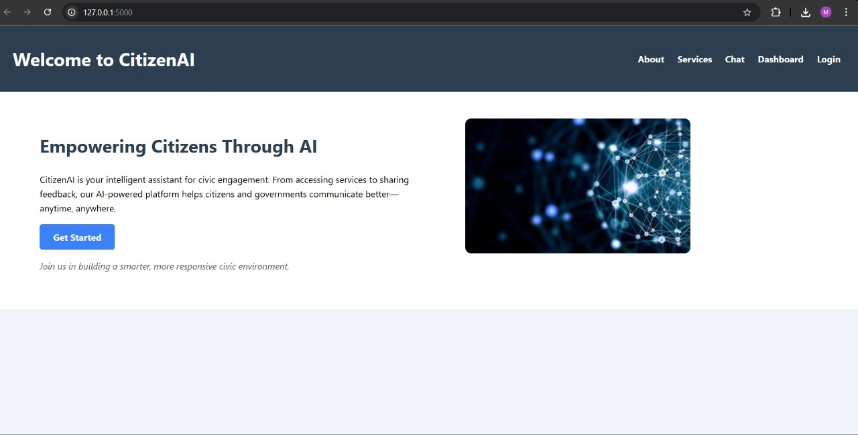

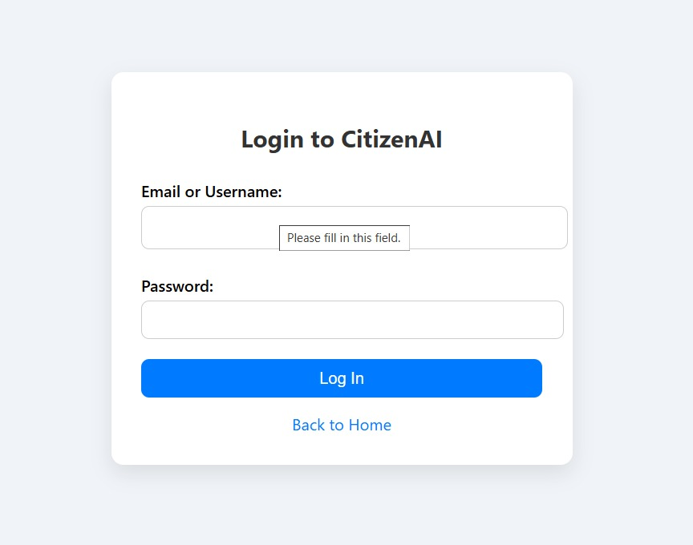

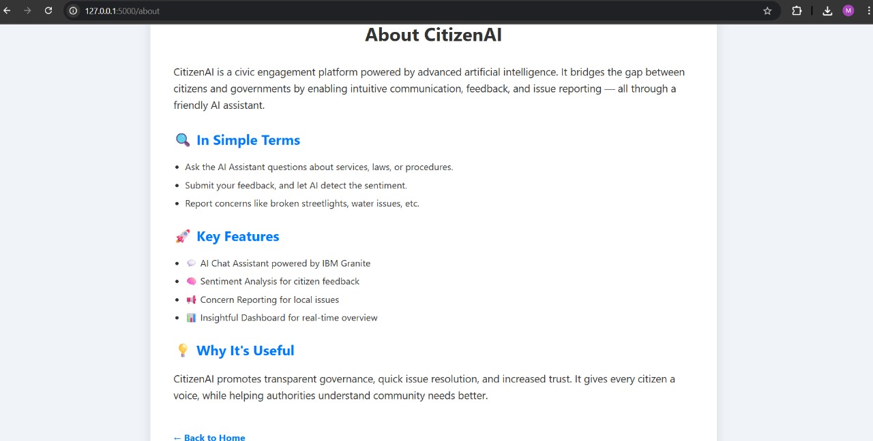

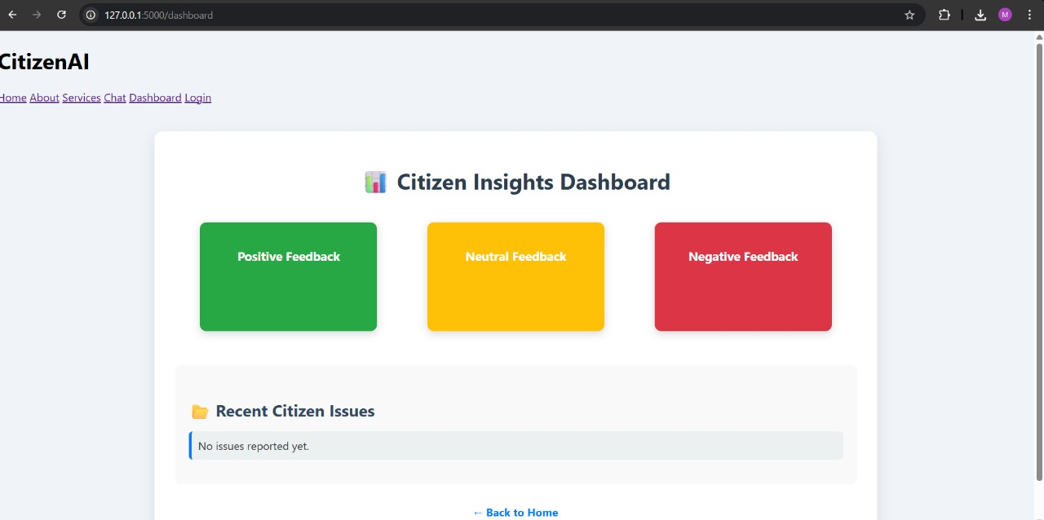

**8. ADVANTAGES& DISADVANTAGES**

**Advantages**

* Unified Civic Communication: Offers a centralized platform for issue reporting, reducing confusion caused by scattered channels.
* AI-Powered Interaction: Chatbot provides instant responses and guides users intuitively, even in multiple languages.
* Improved Transparency: Citizens can track the status of their complaints, building trust in the system.
* Data-Driven Decision Making: Admin dashboards visualize sentiment and issue trends, helping authorities prioritize effectively.
* Inclusive Accessibility: Designed with user-friendly UI for all age groups and literacy levels.

**Disadvantages**

* Internet Dependency: Requires stable connectivity for both citizens and administrators to access features.
* Limited Awareness: Adoption might be slow without awareness campaigns or community outreach.
* Language and Intent Limitations: Chatbot accuracy depends on training data; unfamiliar phrasings may affect understanding.
* Initial Setup Cost: Integration and training for municipal officers may require time and resources.

**9.CONCLUSION**

Citizen AI bridges the gap between citizens and local authorities by offering a smart, AI-driven platform for civic issue reporting. It simplifies communication, ensures faster responses, and promotes transparent, citizen-centric governance—paving the way for smarter cities and more engaged communities.

**10. FUTURE SCOPE**

* Geo-tagging & Image Uploads: Enable users to attach photos and pinpoint exact issue locations using maps.
* WhatsApp & SMS Bot Integration: Expand chatbot access to popular citizen channels for wider adoption.
* Multilingual Voice Interface: Add speech-based interaction to support non-text-savvy users.
* IoT & Sensor Integration: Auto-detect issues like overflowing bins, air quality, or water leaks using smart sensors.
* AI-powered Issue Prioritization: Use ML models to rank complaints based on severity, volume, and location data.
* Predictive Analytics Dashboard: Help administrators forecast recurring issues and allocate resources in advance.
* ULB System Integration: Sync with Urban Local Body systems for automatic work order generation and resolution tracking.

**11. APPENDIX**

**Source Code**

**App.py**

from flask import Flask, render_template, request, redirect, session, url_for

from flask_session import Session

from model import granite_generate_response

from textblob import TextBlob

app = Flask(__name__)

app.secret_key = "your_secret_key"

app.config["SESSION_TYPE"] = "filesystem"

Session(app)

# In-memory storage

chat_history = []

sentiments = []

concerns = []

@app.route("/")

def index():

    return render_template("index.html")

@app.route("/about")

def about():

    return render_template("about.html")

@app.route("/services")

def services():

    return render_template("services.html")

@app.route("/chat", methods=["GET", "POST"])

def chat():

    response, sentiment, submitted = "", "", False

    if request.method == "POST":

        if "question" in request.form:

            question = request.form["question"]

            response = granite_generate_response(question)

            chat_history.append((question, response))

        elif "feedback" in request.form:

            feedback = request.form["feedback"]

            polarity = TextBlob(feedback).sentiment.polarity

            sentiment = "Positive" if polarity > 0 else "Negative" if polarity < 0 else "Neutral"

            sentiments.append(sentiment)

        elif "concern" in request.form:

            concern = request.form["concern"]

            concerns.append(concern)

            submitted = True

    return render_template("chat.html", history=chat_history, sentiment=sentiments[-1:] if sentiments else None, concern_submitted=submitted)

@app.route("/dashboard")

def dashboard():

    pos = sentiments.count("Positive")

    neg = sentiments.count("Negative")

    neu = sentiments.count("Neutral")

    return render_template("dashboard.html", pos=pos, neg=neg, neu=neu, concerns=concerns)

@app.route("/login", methods=["GET", "POST"])

def login():

    if request.method == "POST":

        if request.form["username"] == "admin" and request.form["password"] == "admin":

            session["user"] = "admin"

            return redirect(url_for("dashboard"))

        return render_template("login.html", error="Invalid credentials")

    return render_template("login.html")

@app.route("/logout")

def logout():

    session.clear()

    return redirect(url_for("index"))

if __name__ == "__main__":

    app.run(debug=True)

**Model.py**

from transformers import AutoTokenizer, AutoModelForCausalLM

import torch

model_path = "gpt2"  # much smaller and lightweight

device = "cuda" if torch.cuda.is_available() else "cpu"

print(f"Using device: {device}")

tokenizer = AutoTokenizer.from_pretrained(model_path)

model = AutoModelForCausalLM.from_pretrained(model_path).to(device)

def granite_generate_response(prompt):

    inputs = tokenizer(prompt, return_tensors="pt").to(device)

    output = model.generate(**inputs, max_new_tokens=100)

    return tokenizer.decode(output[0], skip_special_tokens=True)

**Static CSS**

body {

    margin: 0;

    font-family: 'Segoe UI', sans-serif;

    background-color: #f0f4f8;

}

.navbar {

    background-color: #2c3e50;

    color: white;

    padding: 1rem 2rem;

    display: flex;

    justify-content: space-between;

    align-items: center;

}

.navbar nav a {

    color: white;

    margin-left: 1.2rem;

    text-decoration: none;

    font-weight: bold;

}

.navbar nav a:hover {

    text-decoration: underline;

}

.hero-section {

    display: flex;

    justify-content: space-between;

    padding: 3rem 5rem;

    background-color: #fff;

}

.left-panel {

    width: 50%;

}

.left-panel h2 {

    font-size: 2rem;

    color: #2c3e50;

}

.left-panel p {

    font-size: 1rem;

    line-height: 1.6;

    margin: 1rem 0;

}

.btn {

    display: inline-block;

    background-color: #3b82f6;

    color: white;

    padding: 0.75rem 1.5rem;

    border-radius: 5px;

    text-decoration: none;

    font-weight: bold;

}

.btn:hover {

    background-color: #2563eb;

}

.sub-text {

    margin-top: 1rem;

    font-style: italic;

    color: #555;

}

.right-panel {

    width: 45%;

}

.right-panel img {

    width: 100%;

    border-radius: 10px;

}

.hero {

    background-image: url("../Images/images.jpg");

    background-size: cover;

    background-position: center;

    height: 400px;

}

.login-container {

    max-width: 400px;

    margin: 100px auto;

    padding: 30px;

    background-color: #ffffff;

    border-radius: 12px;

    box-shadow: 0 8px 20px rgba(0, 0, 0, 0.1);

    text-align: center;

}

.login-container h2 {

    margin-bottom: 25px;

    color: #333;

}

.login-container label {

    display: block;

    margin: 15px 0 5px;

    text-align: left;

    font-weight: 500;

}

.login-container input {

    width: 100%;

    padding: 10px;

    border: 1px solid #ccc;

    border-radius: 8px;

    font-size: 14px;

}

.login-container button {

    margin-top: 20px;

    width: 100%;

    padding: 10px;

    background-color: #007bff;

    color: white;

    font-size: 16px;

    border: none;

    border-radius: 8px;

    cursor: pointer;

}

.login-container button:hover {

    background-color: #0056b3;

}

.login-container a {

    display: block;

    margin-top: 15px;

    color: #007bff;

    text-decoration: none;

}

.error-message {

    color: red;

    margin-bottom: 15px;

    font-weight: bold;

}

.about-container {

    max-width: 900px;

    margin: 50px auto;

    padding: 40px;

    background: #ffffff;

    border-radius: 10px;

    box-shadow: 0 6px 20px rgba(0,0,0,0.1);

    font-family: 'Segoe UI', sans-serif;

    color: #333;

}

.about-container h1 {

    text-align: center;

    margin-bottom: 30px;

}

.about-container p {

    font-size: 18px;

    line-height: 1.6;

}

section h2 {

    margin-top: 30px;

    color: #007bff;

}

section ul {

    margin-top: 10px;

    padding-left: 20px;

}

section ul li {

    margin-bottom: 10px;

    font-size: 16px;

}

.back-home {

    display: inline-block;

    margin-top: 30px;

    color: #007bff;

    text-decoration: none;

    font-weight: bold;

}

.chat-container {

    max-width: 800px;

    margin: 50px auto;

    padding: 30px;

    background: #fefefe;

    border-radius: 12px;

    box-shadow: 0 6px 20px rgba(0,0,0,0.1);

    font-family: 'Segoe UI', sans-serif;

}

.chat-container h1 {

    text-align: center;

    color: #333;

    margin-bottom: 20px;

}

.chat-section,

.sentiment-section,

.concern-section {

    margin-top: 30px;

}

.chat-section h2,

.sentiment-section h2,

.concern-section h2 {

    color: #007bff;

    margin-bottom: 10px;

}

input[type="text"],

textarea {

    width: 100%;

    padding: 12px;

    border: 1px solid #ccc;

    border-radius: 8px;

    font-size: 15px;

    margin-bottom: 10px;

}

button {

    padding: 10px 20px;

    background-color: #007bff;

    border: none;

    color: white;

    border-radius: 8px;

    cursor: pointer;

    font-size: 16px;

}

button:hover {

    background-color: #0056b3;

}

.response {

    background-color: #f0f8ff;

    padding: 12px;

    border-radius: 8px;

    margin-top: 10px;

    color: #333;

    font-size: 15px;

}

.back-home {

    display: inline-block;

    margin-top: 30px;

    text-decoration: none;

    color: #007bff;

    font-weight: bold;

}

.dashboard-container {

    max-width: 1000px;

    margin: 40px auto;

    padding: 30px;

    background: #ffffff;

    border-radius: 12px;

    box-shadow: 0 8px 20px rgba(0, 0, 0, 0.1);

    font-family: 'Segoe UI', sans-serif;

    text-align: center;

}

.dashboard-container h1 {

    margin-bottom: 30px;

    color: #2c3e50;

}

.summary-section {

    display: flex;

    justify-content: space-around;

    flex-wrap: wrap;

    margin-bottom: 40px;

}

.insight-card {

    width: 220px;

    height: 120px;

    border-radius: 10px;

    color: #fff;

    padding: 20px;

    box-shadow: 0 4px 12px rgba(0, 0, 0, 0.15);

    text-align: center;

    margin: 10px;

    transition: transform 0.2s ease;

}

.insight-card:hover {

    transform: translateY(-5px);

}

.insight-card h3 {

    font-size: 18px;

    margin-bottom: 10px;

}

.insight-card p {

    font-size: 28px;

    font-weight: bold;

}

.positive {

    background-color: #28a745;

}

.neutral {

    background-color: #ffc107;

}

.negative {

    background-color: #dc3545;

}

.issues-section {

    background-color: #f9f9f9;

    padding: 20px;

    border-radius: 10px;

    text-align: left;

}

.issues-section h2 {

    color: #34495e;

    margin-bottom: 15px;

}

.issue-list {

    list-style-type: none;

    padding-left: 0;

    font-size: 16px;

    color: #2d3436;

}

.issue-list li {

    background: #ecf0f1;

    padding: 10px;

    margin-bottom: 8px;

    border-radius: 6px;

    border-left: 4px solid #007bff;

}

.back-link {

    margin-top: 30px;

}

.back-link a {

    text-decoration: none;

    color: #007bff;

    font-weight: bold;

}

.services-section {

    padding: 50px 20px;

    background-color: #f8f9fa;

    text-align: center;

}

.section-title {

    font-size: 2.5rem;

    margin-bottom: 40px;

    color: #333;

}

.services-grid {

    display: grid;

    grid-template-columns: repeat(auto-fit, minmax(280px, 1fr));

    gap: 30px;

    max-width: 1000px;

    margin: auto;

}

.service-card {

    background: #fff;

    padding: 25px;

    border-radius: 12px;

    box-shadow: 0 4px 12px rgba(0,0,0,0.1);

    transition: transform 0.3s ease;

}

.service-card:hover {

    transform: translateY(-5px);

}

.service-card h2 {

    font-size: 1.5rem;

    margin-bottom: 15px;

    color: #007bff;

}

.service-card p {

    font-size: 1rem;

    color: #555;

}

**Image.jpg**



**About.html**

<!DOCTYPE html>

<html lang="en">

<head>

    <meta charset="UTF-8">

    <title>About CitizenAI</title>

    <link rel="stylesheet" href="{{ url_for('static', filename='css/styles.css') }}">

</head>

<body>

    <div class="about-container">

        <h1>About CitizenAI</h1>

        <p>

            CitizenAI is a civic engagement platform powered by advanced artificial intelligence.

            It bridges the gap between citizens and governments by enabling intuitive communication, feedback, and issue reporting — all through a friendly AI assistant.

        </p>

        <section class="simple-terms">

            <h2>🔍 In Simple Terms</h2>

            <ul>

                <li>Ask the AI Assistant questions about services, laws, or procedures.</li>

                <li>Submit your feedback, and let AI detect the sentiment.</li>

                <li>Report concerns like broken streetlights, water issues, etc.</li>

            </ul>

        </section>

        <section class="key-features">

            <h2>🚀 Key Features</h2>

            <ul>

                <li>💬 AI Chat Assistant powered by IBM Granite</li>

                <li>🧠 Sentiment Analysis for citizen feedback</li>

                <li>📢 Concern Reporting for local issues</li>

                <li>📊 Insightful Dashboard for real-time overview</li>

            </ul>

        </section>

        <section class="why-useful">

            <h2>💡 Why It's Useful</h2>

            <p>

                CitizenAI promotes transparent governance, quick issue resolution, and increased trust.

                It gives every citizen a voice, while helping authorities understand community needs better.

            </p>

        </section>

        <a href="{{ url_for('index') }}" class="back-home">← Back to Home</a>

    </div>

</body>

</html>

**Base.html**

<!DOCTYPE html>

<html>

<head>

    <title>{% block title %}CitizenAI{% endblock %}</title>

    <link rel="stylesheet" href="{{ url_for('static', filename='css/styles.css') }}">

</head>

<body>

    <header>

        <h1>CitizenAI</h1>

        <nav>

            <a href="{{ url_for('index') }}">Home</a>

            <a href="{{ url_for('about') }}">About</a>

            <a href="{{ url_for('services') }}">Services</a>

            <a href="{{ url_for('chat') }}">Chat</a>

            <a href="{{ url_for('dashboard') }}">Dashboard</a>

            <a href="{{ url_for('login') }}">Login</a>

        </nav>

    </header>

    <main>

        {% block content %}{% endblock %}

    </main>

</body>

</html>

**Chat.html**

{% extends 'base.html' %}

{% block title %}Chat{% endblock %}

{% block content %}

<h2>Ask the Assistant</h2>

<form method="POST">

    <input type="text" name="question" placeholder="Enter your question..." required>

    <button type="submit">Submit</button>

</form>

{% if history %}

<ul>

  {% for q, a in history %}

    <li><strong>You:</strong> {{ q }}<br><strong>AI:</strong> {{ a }}</li>

  {% endfor %}

</ul>

{% endif %}

<h2>Feedback Sentiment</h2>

<form method="POST">

    <textarea name="feedback" required></textarea>

    <button type="submit">Analyze</button>

</form>

{% if sentiment %}

<p>Sentiment: <strong>{{ sentiment }}</strong></p>

{% endif %}

<h2>Report a Concern</h2>

<form method="POST">

    <textarea name="concern" required></textarea>

    <button type="submit">Submit</button>

</form>

{% if concern_submitted %}

<p class="response">Concern submitted successfully ✅</p>

{% endif %}

{% endblock %}

**Dashboard.html**

{% extends "base.html" %}

{% block content %}

<div class="dashboard-container">

    <h1>📊 Citizen Insights Dashboard</h1>

    <section class="summary-section">

        <div class="card insight-card positive">

            <h3>Positive Feedback</h3>

            <p>{{ positive_count }}</p>

        </div>

        <div class="card insight-card neutral">

            <h3>Neutral Feedback</h3>

            <p>{{ neutral_count }}</p>

        </div>

        <div class="card insight-card negative">

            <h3>Negative Feedback</h3>

            <p>{{ negative_count }}</p>

        </div>

    </section>

    <section class="issues-section">

        <h2>📂 Recent Citizen Issues</h2>

        <ul class="issue-list">

            {% for issue in recent_issues %}

                <li>🛠️ {{ issue }}</li>

            {% else %}

                <li>No issues reported yet.</li>

            {% endfor %}

        </ul>

    </section>

    <div class="back-link">

        <a href="/">← Back to Home</a>

    </div>

</div>

{% endblock %}

**Index.html**

<!DOCTYPE html>

<html lang="en">

<head>

    <meta charset="UTF-8">

    <title>CitizenAI - Welcome</title>

    <link rel="stylesheet" href="{{ url_for('static', filename='css/styles.css') }}">

</head>

<body>

    <!-- Navbar -->

    <header class="navbar">

        <h1>Welcome to CitizenAI</h1>

        <nav>

            <a href="{{ url_for('about') }}">About</a>

            <a href="{{ url_for('services') }}">Services</a>

            <a href="{{ url_for('chat') }}">Chat</a>

            <a href="{{ url_for('dashboard') }}">Dashboard</a>

            <a href="{{ url_for('login') }}">Login</a>

        </nav>

    </header>

    <!-- Hero Section -->

    <main class="hero-section">

        <div class="left-panel">

            <h2>Empowering Citizens Through AI</h2>

            <p>

                CitizenAI is your intelligent assistant for civic engagement.

                From accessing services to sharing feedback, our AI-powered platform helps citizens and governments communicate better—anytime, anywhere.

            </p>

            <a href="{{ url_for('login') }}" class="btn">Get Started</a>

            <p class="sub-text">Join us in building a smarter, more responsive civic environment.</p>

        </div>

        <div class="right-panel">

            <img src="{{ url_for('static', filename='Images/images.jpg') }}" alt="CitizenAI Image" style="width: 400px; border-radius: 10px;">

        </div>

    </main>

</body>

</html>

**Login.html**

<!DOCTYPE html>

<html lang="en">

<head>

    <meta charset="UTF-8">

    <title>CitizenAI Login</title>

    <link rel="stylesheet" href="{{ url_for('static', filename='css/styles.css') }}">

</head>

<body>

    <div class="login-container">

        <h2>Login to CitizenAI</h2>

        <!-- Show error message if login fails -->

        {% if error %}

            <p class="error-message">{{ error }}</p>

        {% endif %}

        <form method="POST" action="{{ url_for('login') }}">

            <label for="username">Email or Username:</label>

            <input type="text" id="username" name="username" required>

            <label for="password">Password:</label>

            <input type="password" id="password" name="password" required>

            <button type="submit">Log In</button>

        </form>

        <a href="{{ url_for('index') }}">Back to Home</a>

    </div>

</body>

</html>

**Services.html**

{% extends "base.html" %}

{% block content %}

<div class="container">

    <h1 class="text-center mt-5 mb-4">Our Services</h1>

    <div class="row">

        <div class="col-md-6 mb-4">

            <div class="card shadow p-3">

                <h4>🤖 AI Chat Assistant</h4>

                <p>Get instant answers to your civic-related questions with our AI powered by IBM Granite.</p>

            </div>

        </div>

        <div class="col-md-6 mb-4">

            <div class="card shadow p-3">

                <h4>📢 Report Concerns</h4>

                <p>Easily report civic issues like garbage, water, lighting, etc., to local authorities.</p>

            </div>

        </div>

        <div class="col-md-6 mb-4">

            <div class="card shadow p-3">

                <h4>📊 Sentiment Analysis</h4>

                <p>Track how people feel about issues—positive, negative, or neutral—in real time.</p>

            </div>

        </div>

        <div class="col-md-6 mb-4">

            <div class="card shadow p-3">

                <h4>🔐 User Dashboard</h4>

                <p>Secure login to view reports, analytics, and submitted concerns.</p>

            </div>

        </div>

    </div>

</div>

{% endblock %}

**GitHub Link :** https://github.com/MounikaChanduu/CitizenAI.git

**ProjectDemoLink:**https://drive.google.com/file/d/1RhBmCiGWirlaHP57FJbkes8U4Ksht6dr/view?usp=drivesdk